BAIZONN LEARNING CENTER

**Initial Website**

I have developed a basic website which every group can use as reference only

<http://www.baizonn.com/>

Related website for your reference

<https://www.thelearninglab.com.sg/contact-us/our-locations/>

================================

**Getting there and CONTACT US**

General Inquiries: 62811816, or BaizonnLearning@gmail.com

Address = 1007A Upper Serangoon Road

================================

**About Center**

“Home” tab

Welcome to BAIZONN

Founded in 2018, we believe in Establishing a Strong Foundation build on Grasping Maths and Science Principles.

At Baizonn, we Equip your child to ace the semester. We provide up-to-date curriculum and targeted lesson to set your child up for success in the coming terms.

F.A.S.T. = Firm Foundation, Apply, Surpass, Top

S.T.E.M : Science, Technology, Engineering, Maths

“About Us” tab



**Nurturing a Love For Learning**

For over 5 years, we help students achieve success in school and in life by nurturing a love for learning.

From primary school to junior college, our students enjoy fun, interactive and relevant lessons and are empowered to think beyond the confines of the classroom.

**Preparing Students To Achieve Success**

Developing Confident and Successful Learners

Our students are at the centre of everything we do and their well-being and success in learning matter to us.

While we educate our students, we also equip them with the right knowledge, skills and attitudes that help them solve problems, think big and seek excellence.

**Passionate Teachers That Make A Difference**

Our teachers motivate and nurture every student to achieve their best and to build the right attitudes to ingrain a love for learning.

We hire teachers with the right passion and qualifications, and equip them to create amazing classroom experiences for their students.

We're committed to bringing out the best in every student.

“Registration” tab

Join Us at Baizonn!

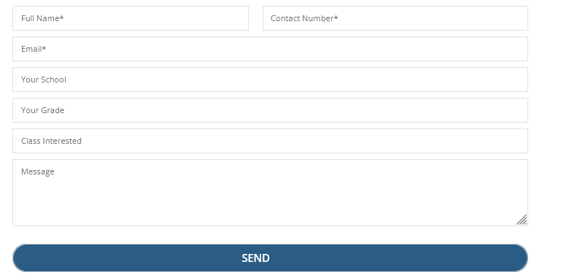

(For demonstration only)

“Schedule” tab

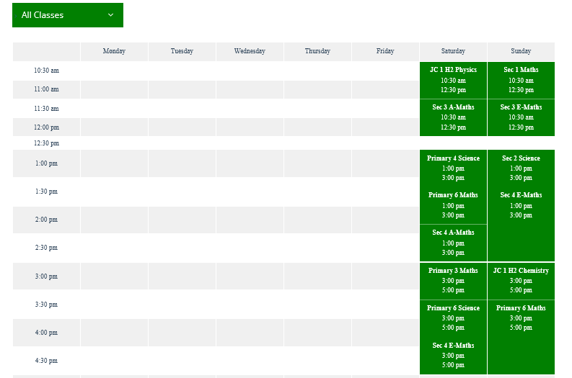

(For demonstration only)

================================

**Subjects offer**

Science

Primary 3-6 Science

Secondary 1-2 Science

Secondary 3-4 Science

Junior College 1-2 Science

Mathematics

Primary 3-6 Mathematics

Secondary 1-2 Mathematics

Secondary 3-4 Mathematics

Junior College 1-2 Mathematics

Advanced Courses

Integrated Programme (IP) Mathematics and Science

International Baccalaureate (IB) Mathematics and Science

================================

**Academic Partner**

NATIONAL INSTRUMENTS

Academic Channel Partner for S.T.E.M.

================================

**Awards**

Winner of Editor’s Choice Awards for 2016 Engineering Impact Awards ASEAN / ANZ Regional Contest

“A Smart Recirculating Aquaculture System”

================================

**Current sessions for 2022**

|  |  |  |
| --- | --- | --- |
| Subjects | Weekdays | Weekends |
| Primary 3-6  Science  Monthly $100 | Mon, 4pm - 6pm, 7pm - 9pm  Wed, 4pm - 6pm, 7pm - 9pm  Fri, 4pm - 6pm, 7pm - 9pm | Sat, 8am – 10am, 1pm - 3pm  Sun, 8am – 10am, 1pm - 3pm |
| Primary 3-6  Math  Monthly $100 | Mon, 4pm - 6pm, 7pm - 9pm  Wed, 4pm - 6pm, 7pm - 9pm  Fri, 4pm - 6pm, 7pm - 9pm | Sat, 8am – 10am, 1pm - 3pm  Sun, 8am – 10am, 1pm - 3pm |
| Secondary 1-2 Science  Monthly $150 | Tue, 4pm - 6pm, 7pm - 9pm  Thu, 4pm - 6pm, 7pm - 9pm | Sat, 10am – 12pm, 4pm – 6pm  Sun, 10am – 12pm, 4pm – 6pm |
| Secondary 1-2  Math  Monthly $150 | Tue, 4pm - 6pm, 7pm - 9pm  Thu, 4pm - 6pm, 7pm - 9pm | Sat, 10am – 12pm, 4pm – 6pm  Sun, 10am – 12pm, 4pm – 6pm |
| Secondary 3-4 Science  Monthly $200 | Tue, 4pm - 6pm, 7pm - 9pm  Thu, 4pm - 6pm, 7pm - 9pm | Sat, 10am – 12pm, 4pm – 6pm  Sun, 10am – 12pm, 4pm – 6pm |
| Secondary 3-4  Math  Monthly $200 | Tue, 4pm - 6pm, 7pm - 9pm  Thu, 4pm - 6pm, 7pm - 9pm | Sat, 10am – 12pm, 4pm – 6pm  Sun, 10am – 12pm, 4pm – 6pm |
| JC 1-2 Science  Monthly $250 | Mon, 4pm - 6pm, 7pm - 9pm  Wed, 4pm - 6pm, 7pm - 9pm  Fri, 4pm - 6pm, 7pm - 9pm | Sat, 8am – 10am, 1pm - 3pm  Sun, 8am – 10am, 1pm - 3pm |
| JC 1-2  Math  Monthly $250 | Mon, 4pm - 6pm, 7pm - 9pm  Wed, 4pm - 6pm, 7pm - 9pm  Fri, 4pm - 6pm, 7pm - 9pm | Sat, 8am – 10am, 1pm - 3pm  Sun, 8am – 10am, 1pm - 3pm |

================================

**Promotions**

For students that enrolled into 2 subjects, there will be 5% discount on the monthly fees.

For students that enrolled into 3 subjects, there will be 10% discount on the monthly fees.

================================